**ASSIGNMENT 2 - ACCESSIBILITY**

I have used WAVE and AVE developer tools to evaluate accessibility and responsiveness of my website.

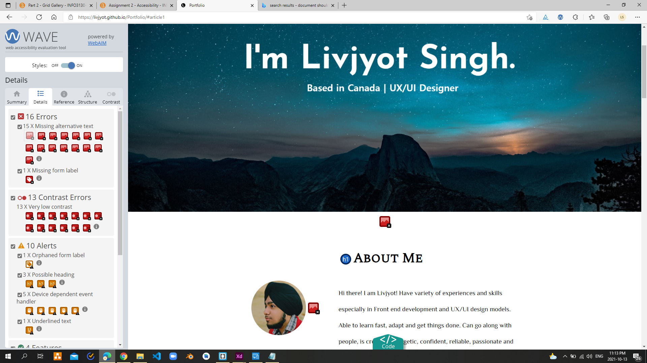

WAVE Tool

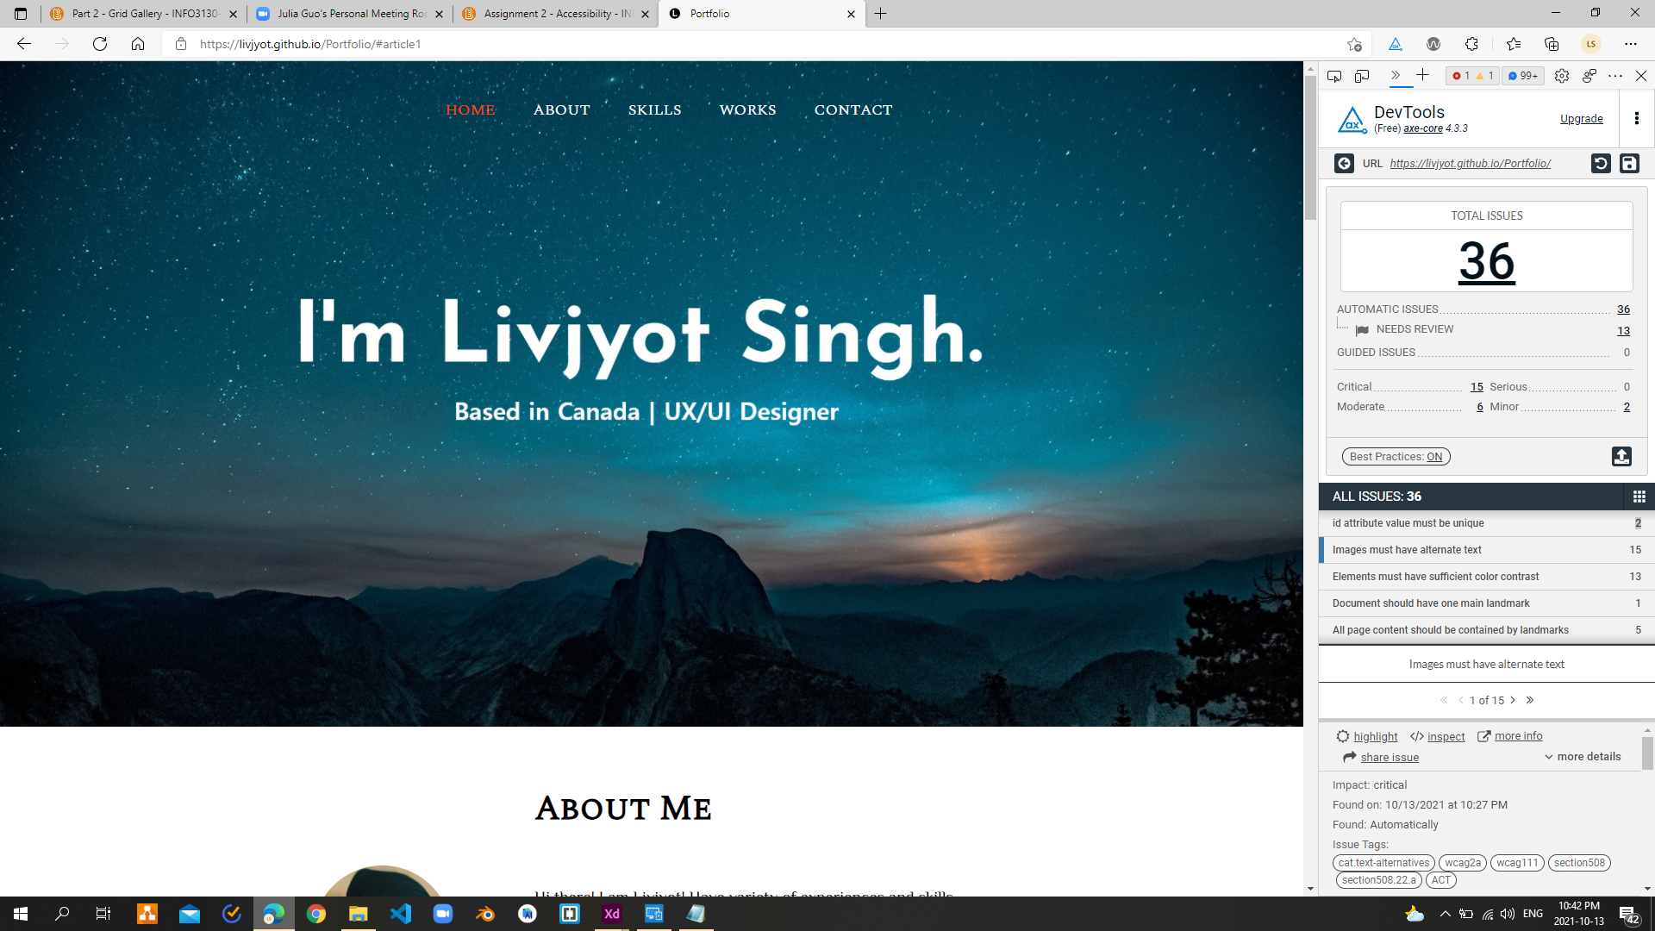

AVE Developer Tool

In the Wave plugin, I checked the accessibility of the website. And there I found 16 errors in which most of them were “Missing Alt. Text” for background images and icons. Also, I could see some contrast errors which meant that the website had relatively poor contrast and lacks in making it accessible.

In the Ave Developer’s Tool, I found some major issues which were same as above. Like missing alt. text and elements must have sufficient color contrast and some other minors.

By solving these issues, I can make my website fully accessible which would help impaired people to have full access and control on the site and will meet Web Content Accessibility Guidelines (WCAG).

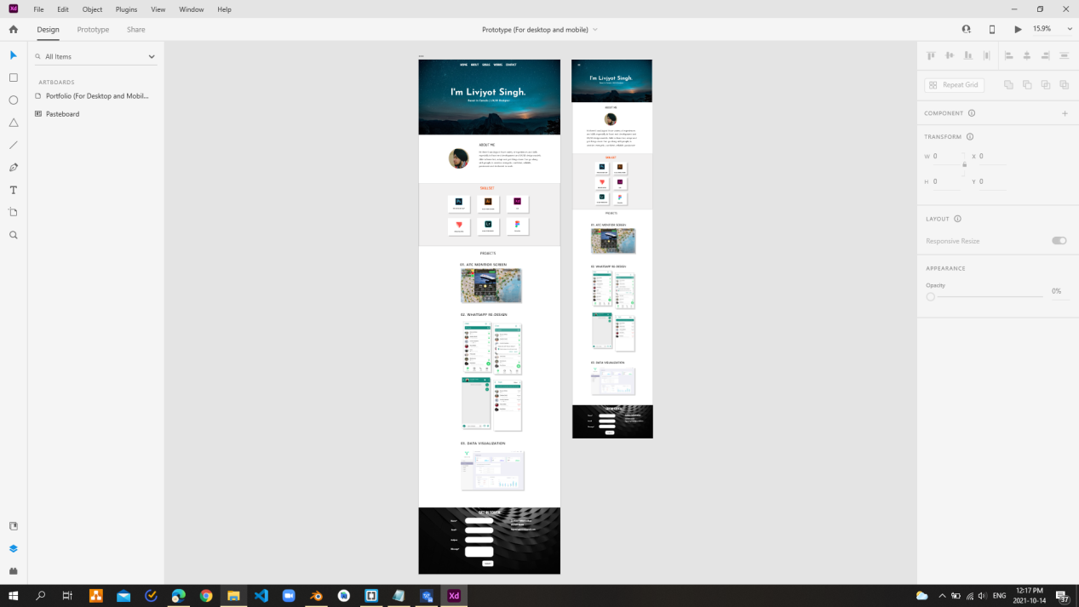

Adobe XD

To check the responsiveness, I have designed the portfolio site both for desktop and mobile screens so that it is fully responsive and accessible to all without any device restrictions.